

**Name:**

**Placement:**

# Volunteer

**Application Form**

**Title:** Mr / Mrs / Miss / Ms

Surname:

Forename(s):

Address:

Postcode:

|  |
| --- |
| **Email:**  **Please tick if you are happy to use this for correspondence** |

Telephone – Home:

Work (if we may call you there):

Date of birth:

(NB we cannot accept applications from people under the age of 17 years)

**Please tick as appropriate**

**Retired Previous Occupation……………………………………………….**

**Employed Student**

**Unemployed O Other**

Next of kin:

Relationship of Next of Kin:

Address for next of kin:

Postcode: Emergency contact number:

**Do you already know what type of volunteering you would like to offer?** (If so please give details below)

**Do you have any particular skills you can share with our patients?** (If so please give details below)

Please state where you heard about our need for volunteers:

The Disability Discrimination Act 1995 defines a person as having a disability if he or she “has a physical or mental impairment which has a substantial and long-term adverse effect on his or her ability to carry out normal day to day activities”.

Do you have such a disability? Yes🞏 No🞏

|  |  |  |  |  |  |  |  |
| --- | --- | --- | --- | --- | --- | --- | --- |
| **Please tick the sessions when you would be available for volunteering and cross out the sessions where you would definitely not be available.** | | | | | | | |
|  | MON | TUE | WED | THURS | FRID | SAT | SUN |
| Morning |  |  |  |  |  |  |  |
| Afternoon |  |  |  |  |  |  |  |
| Evening |  |  |  |  |  |  |  |

**Please provide names and addresses of two referees (not relatives) whom we may approach for**

**References, e.g.: employer, teacher, religious leader. You need to have known your referees for at**

**least 3 years.**

**Referee 1:** Name:

Address: Postcode: Telephone:

Email:

**Referee 2:** Name:

Address: Postcode:

Telephone:

Email:

**Can you arrange transport to the hospital?** (Delete as appropriate) Yes / No

Car  Motorcycle/Moped 

Bicycle  Public Transport 

If yes, do you use:

**Requirements under the Rehabilitation of Offenders Act 1974**

Because of the nature of the work for which you are applying, this post is exempt from the provisions of section 4(2) of the Rehabilitation Act 1974 by virtue of the Rehabilitation of Offenders Act 1974 (Exceptions) Order 1975. Applicants are therefore not entitled to withhold information about convictions/cautions even those, which for other purposes are spent under the provision of the Act, and in the event of employment, any failure to disclose any convictions or cautions could result in dismissal. Any information given will be completely confidential and will be considered only in relation to an application for positions to which the order applies.

**Have you had any previous convictions/cautions (delete as appropriate) - Yes** / No*

|  |  |  |  |
| --- | --- | --- | --- |
|  |  | |  |
|  | |  | |

The Voluntary Services Department operates under the Trust’s Equal Opportunity Policy

|  |  |
| --- | --- |
| **I give my consent to Voluntary Services to take up references** |  |
| **I confirm that the personal information supplied by me is accurate** |  |

**DATA PROTECTION ACT 1998**

Should your application to volunteer be successful, Queen Elizabeth Hospital, Kings Lynn will need to hold and process personal information about you. This includes information, which is required for equal opportunities monitoring purposes.

I give my consent for Queen Elizabeth Hospital, Kings Lynn to hold and process personal information about me, in accordance with the above requirements.

I confirm that the above statements are true and correct, and understand that any misrepresentation will invalidate my application. All volunteers are required to have an Occupational Health screening. I am prepared to undergo a medical examination if requested.

**I understand and confirm that I will not divulge any information I receive which may be confidential.**

I understand that there will be no payment for duties performed in a voluntary capacity and that it may be necessary to change my place of duty within the hospital.

**Signed:** ……………………………………………………………………………………………………… **Date:** ……………………….

When you have completed your application form, please contact:

Paul Holley-Smith

Voluntary Services Manager

The Queen Elizabeth Hospital

Gayton Road

Kings Lynn

Norfolk

PE30 4ET

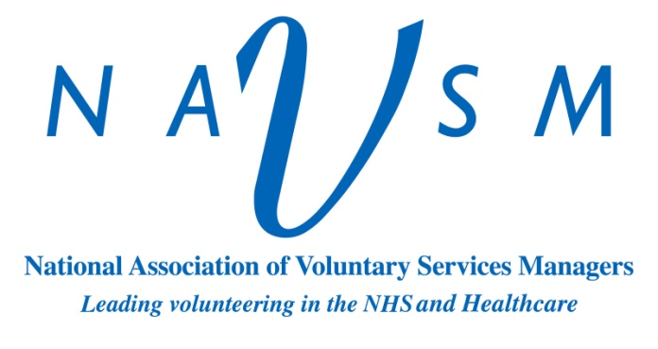

Tel: 01553 613613 Ext: 4687

Paul.Holley-Smith@qehkl.nhs.uk

General Admin Enquiries

Telephone – 01553 613205

|  |
| --- |
| **For office use only:** |
| **Date of Interview:** |
| **Placement:** |
|  |
| **Start Date:** |

PHS/V4 Nov 2016