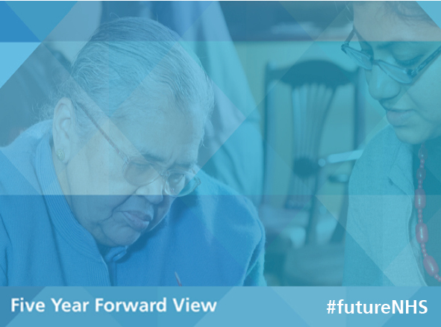
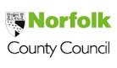
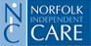

Norfolk and Waveney Sustainability and Transformation Plan
STP briefing 1 - May 2016

The demographic and geography of Norfolk and Waveney combined with significant pressures on public funding has rendered the current structure and approach of health and social care unsustainable. This is not a local problem, it is being experienced across the country.
We recognise that unless we as health and social care organisations innovate and successfully implement change together we will not be able to continue to offer customer orientated, safe and sustainable quality services.
Fifteen health and care organisations came together in October 2015 to form the Norfolk and Waveney Health and Care Partnership (NWHCP) and we are working to develop a Sustainability and Transformation Plan (STP) for our local population. Ours is one of 44 STPs being developed in England, in local areas known as ‘footprints’. We need to make an initial submission to NHS England by 30th June, 2016. This will form the basis of discussions with stakeholders and NHS England over the coming months.
Our partnership comprises the five NHS Clinical Commissioning Groups, three hospital trusts, Norfolk Community Health and Care, Norfolk and Suffolk FT (mental health), East Coast Community Healthcare, East of England Ambulance Service, Norfolk County Council (including Public Health), the Norfolk and Waveney Local Medical Committee and Norfolk Independent Care. Our partnership is chaired by the Chief Executive of Norfolk County Council, Wendy Thomson.

Background
The NHS Five Year Forward View identifies three “gaps” which each STP must address:
- Improving health and wellbeing – we need a “radical upgrade in prevention, patient activation, choice and control, and community engagement”.
- Improving quality and developing new models of care
- Improving efficiency to achieve financial balance

There are also some priorities that we as a local partnership know are key to everything we do:
- We want more care closer to home
- We need a thriving and sustainable acute (hospital) sector
- We must focus on preventing illness and promoting wellbeing
- We can do more by closer and integrated working
- We have got to provide services in the budget we have - affordability is vital

Our response so far - how we are developing the STP
Across Norfolk and Waveney and within each CCG locality, much is already being done to address the “gaps” which are highlighted in the 5YFV. New models of care are being developed to suit local need, quality-driven efficiencies are being sought and implemented and we are helping people change their lifestyles.
Our agreed aims are to change the way we work together to develop a culture of collaboration to achieve integrated compassionate care across the system, to tackle the distress and challenges in the system by developing both sustainable models of care and sustainable financial models across organisational boundaries.
We have established the following ‘workstreams’ to drive forward our STP planning:
- Keeping me at Home
- Future Care & Sustainability – Primary & Community
- Future Care & Sustainability – Acute
- Prevention and Wellbeing
- Finance
- Enablers including Workforce, ICT and Estates
Mental health is a part of everything we do and will feature across all workstreams. Also underpinning them are principles we would want for our patients and clients:
- Looking at me as a whole person
- Keeping me at my home as much as possible
- Having one person to connect to for my care and who is easy to get hold of
- Outcomes that are important to me are what matter in my care
- People who care for me talk to each other
- One visit not 5
- I will get good care any time, any day
- I can trust who sees me
- My time is precious

Further information, feedback and public engagement
We want to take into account the insights and opinions of the Norfolk and Waveney community, including staff, elected representatives, patient/care groups and members of the public. We have published some useful documents including an early “checkpoint submission” to NHS England at http://www.healthwatchnorfolk.co.uk/reports-and-papers/sustainability-and-transformation-plan/ and on the partners’ websites. You can leave your feedback and suggestions about the checkpoint document and our high-level priorities here.
The full guidance for developing STPs can be found at https://www.england.nhs.uk/wp-content/uploads/2015/12/planning-guid-16-17-20-21.pdf.
The challenge of the requirements and timeframe set for the STP give us practical difficulties in securing full engagement of the many important stakeholders in our health and social care system. At this stage, we are sharing the high level narrative and in the months to come we plan a full engagement programme so that everyone’s voice is heard and we can develop the Norfolk and Waveney STP together.

