North Cambs Hospital
From A1101
Long Sutton

The Park, Wisbech, Cambs. PE13 3AB
Tel: 01945 488088

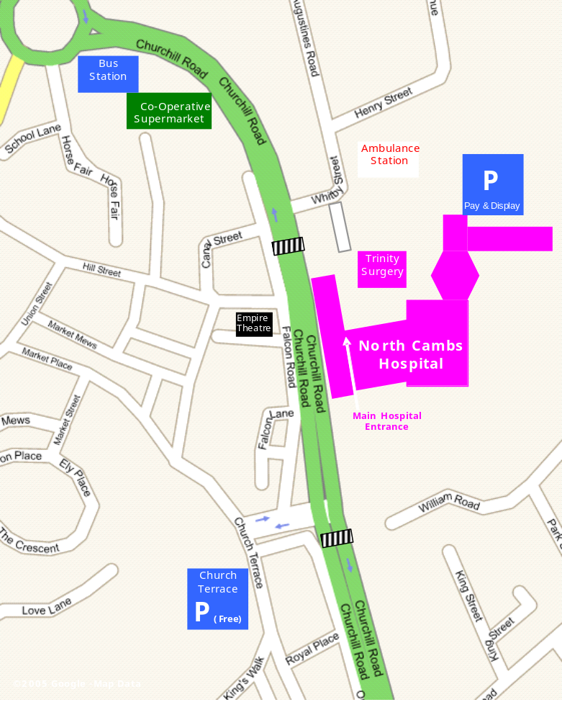
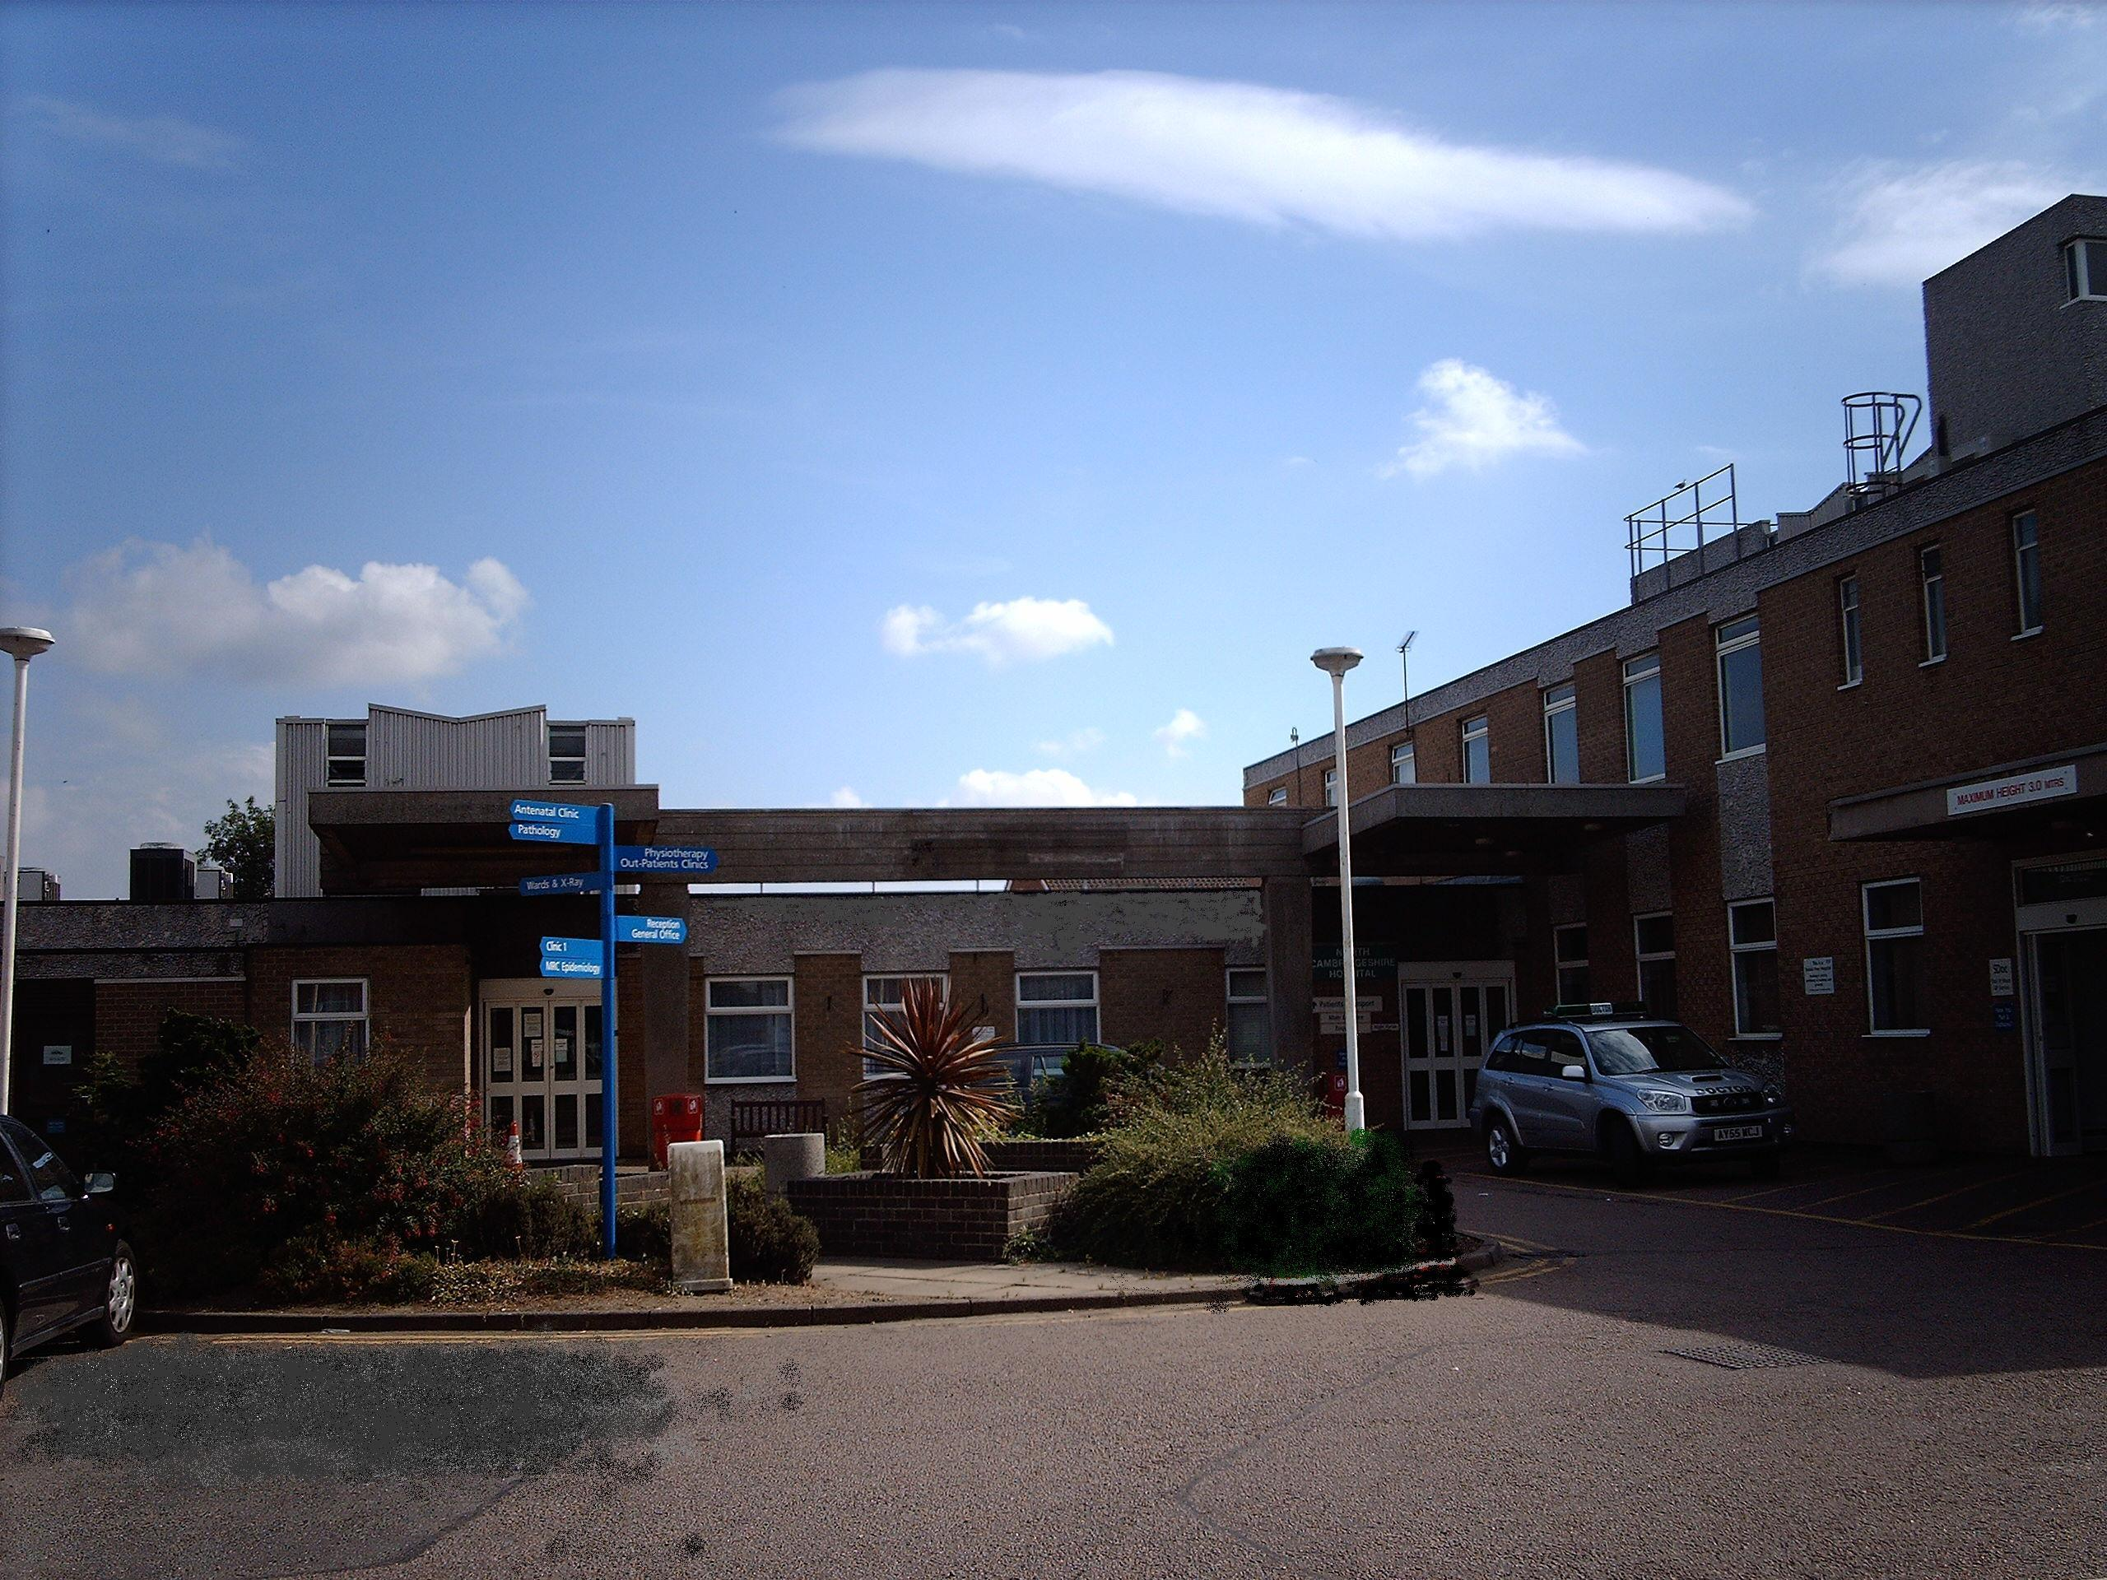
North Cambs Hospital

P
From a47 bypass
P’Boro/Kings Lynn

