Training the PneuX

The videos below can be used as guidance for intubation and tube exchange;

**

Further training documents and information can be shared. Please contact one of the team if you would like further information on training.

Implementation

In order to support the implementation of PneuX™ the Oxford AHSN has produced the following;

An implementation booklet – to guide clinicians on how to introduce the innovation into their hospital

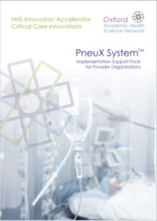

A video to show how the innovation works

https://www.youtube.com/watch?v=OaqCyZFxrjg

