The Design of the System

- The Cuff

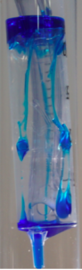

Standard Endotracheal Tube (ETT) has a cuff that creases and folds, allowing leakage of subglottic secretions. (syringe represents the patient’s trachea)

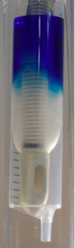

The PneuX™ novel silicone cuff has no folds and no creases, creating a perfect seal on the trachea and in turn, preventing aspiration of subglottic secretions (Syringe represents the patient’s trachea)

- The Subglottic Ports

National recommendations for the prevention of VAP include using tracheal tubes that allow subglottic drainage.
The PneuX™ meets this standard and boasts three subglottic ports to allow for the removal of subglottic secretions. The 3 ports are larger than on a standard tube to decrease the incidence of blockage.

In addition to this, and because of the secure seal the silicone cuff has formed, the PneuX™ also allows for subglottic irrigation. The patient’s trachea can be irrigated with high volumes of normal saline, cleaning the subglottic space and mouth and preventing tracheal colonisation.

The system has 3 ports as shown in this video
https://youtu.be/LhnxIHjsDpA

- The Tracheal Seal Monitor (TSM)

The system includes the TSM which should be used to keep the cuff correctly inflated at all times, it compensates for tube movement continuously and rapidly.
The system should not be used with any other cuff inflation device.

