The PneuX™ System – Endotracheal and Tracheostomy Tubes

Ventilator-associated pneumonia (VAP) is the leading infective hospital acquired cause of mortality on the Intensive Care Unit (ICU).
If a patient develops VAP, it increases their length of stay in the ICU, increases their risk of mortality and has high cost implications for the NHS – Read more here
VAP is caused by leakage of bacteria laden oral and gastric secretions past the endotracheal tube and into the lungs. Leakage of these secretions occurs in standard tubes because of the folds that form in the cuffs of endotracheal tubes inside the patient’s trachea.

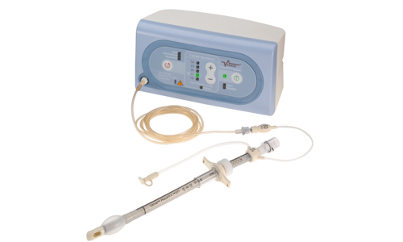

Supported By;

FAB Awards Finalist (2016)

2nd Cleveland Clinic Top Ten Award (2010)

Patient’s Opinions – East of England Citizens Senate, 2015.

100% (13/13) of all patients surveyed said that they would want PneuX™ system used in ICUs for their benefit and for their families.

“In ICU I want the highest chance of recovering”

“This device is clearly cost effective in preventing pneumonia in intensive care and should be used in all NHS hospitals”

“This device is critical to patient safety. We must collectively influence the commissioners to invest in this”

“I fail to see how any well-informed clinician or patient would opt to use a device other than this. Who would choose the acid-and-bugs-in-the-lung option?”

“Practical and safe especially in reducing health issues and stopping further complications”
The Endotracheal PneuX™ Tube at a Glance

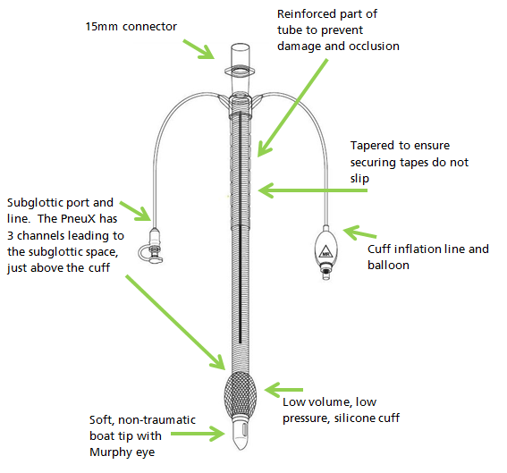

The Tracheal Seal Monitor (TSM)

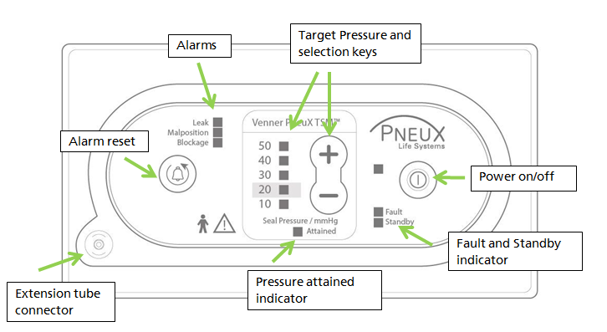

Please follow the links below for further information:

- The System Design

- Training and Implementation

- Procurement/ Costs

- Clinical Evidence

- Clinical Studies

- Laboratory Studies

- Cost Saving in the NHS

If you require any further information, please get in touch via email klipsuk@gmail.com

