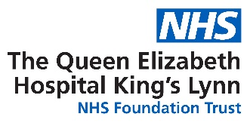

ANTIBODY TEST FOR SARS-COV-2

INFORMATION FOR PATIENTS

What is an antibody test?
An antibody test can tell someone whether they have had the virus that causes Covid-19 in the past, by analysing a blood sample.

What do antibody test results mean?
A positive antibody test demonstrates that someone has developed antibodies to the virus. The presence of antibodies signals that the body has staged an immune response to the virus.

Covid-19 is a new disease, and our understanding of the body’s immune response to it is limited. We do not know, for example, how long an antibody response lasts, nor whether having antibodies means you cannot transmit the virus to others. Our understanding of the virus will grow as new scientific evidence and studies emerge.

An antibody test result can only tell an individual whether or not they have had the virus in the past. Antibody tests are also being used currently in surveillance studies, to understand what proportion of the population have already had the virus.

If you test positive for antibodies, can you ignore lockdown restrictions?
No. There is no evidence yet to suggest that those who have been proven to have had the virus are immune. This is the position of the World Health Organisation.

You should continue to comply with social distancing measures and government guidelines.

How will I be informed of the result & where will this be stored?
You will be informed of your result by telephone or text message as our technology evolves.

How will my information be used?
The anonymised results across the testing programme will provide information on the prevalence of COVID-19 in different regions of the country and help better understand how the disease spreads.

Are there any risks to having the test?
There are some risks related to having a blood test, such as feeling dizzy and faint during and after the test but nothing specific to this antibody test. Risks can also include bruising at the venepuncture site. Serious complications such as an infection at the site where blood was taken and phlebitis (swelling of the vein) are possible but generally extremely unlikely.

