**Header here (Arial 14pt)**

Body copy goes here (Arial 12pt)



This document can be provided in different languages and formats.  
For more information please contact:

[Department Name]  
The Queen Elizabeth Hospital King’s Lynn NHS Foundation Trust  
Gayton Road, King’s Lynn PE30 4ET  
Tel: 01553 613613

Name, Department © MONTH 2020. All rights reserved. The Queen Elizabeth Hospital King’s Lynn NHS Foundation Trust. Review July 2021.

Ref: (if applicable)

**Feedback**

We appreciate and encourage feedback. If you need advice or are concerned about any aspect of care of treatment, please speak to a member of staff or contact the Patient Advice and Liaison Service (PALS):

**Telephone:** 01553 613351 or 01553 613343  
**Email:** pals@qehkl.nhs.uk  
**Letter:** PALS, The Queen Elizabeth Hospital King’s Lynn NHS Foundation Trust, Gayton Road, King’s Lynn PE30 4ET

The Trust endeavours to ensure that the information given here is accurate and impartial.

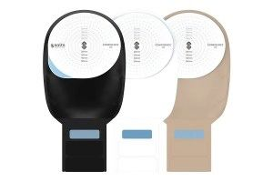

**Please contact us with any stoma related issues!**

**If we don't know there’s a problem we can’t help!**

