Rehabilitation Services

Physiotherapy

Knee Replacement

What to expect and how to prepare yourself

Patient Information

Introduction

This booklet has been prepared to give you some information on:

- What a knee replacement is.
- Preparation prior to your operation.
- Recovery from your operation.
- How to manage at home.

The knee joint

The knee is one of the most complicated joints in the body. It works like a hinge but also allows a limited amount of twisting. It is made up of three main bones – the femur (thigh bone), tibia (shin bone), and patella (knee cap).

The knee is one of the main load-bearing joints in the body; therefore, it is prone to 'wear and tear' and the onset of arthritis. There are two types of knee replacement surgery depending on the extent of your arthritis – a uni-compartmental [A] (replacing half the joint) or total [B] (replacing both compartments).

Following this surgery most patients are discharged within 24hrs, in some cases this could mean going home the same evening.

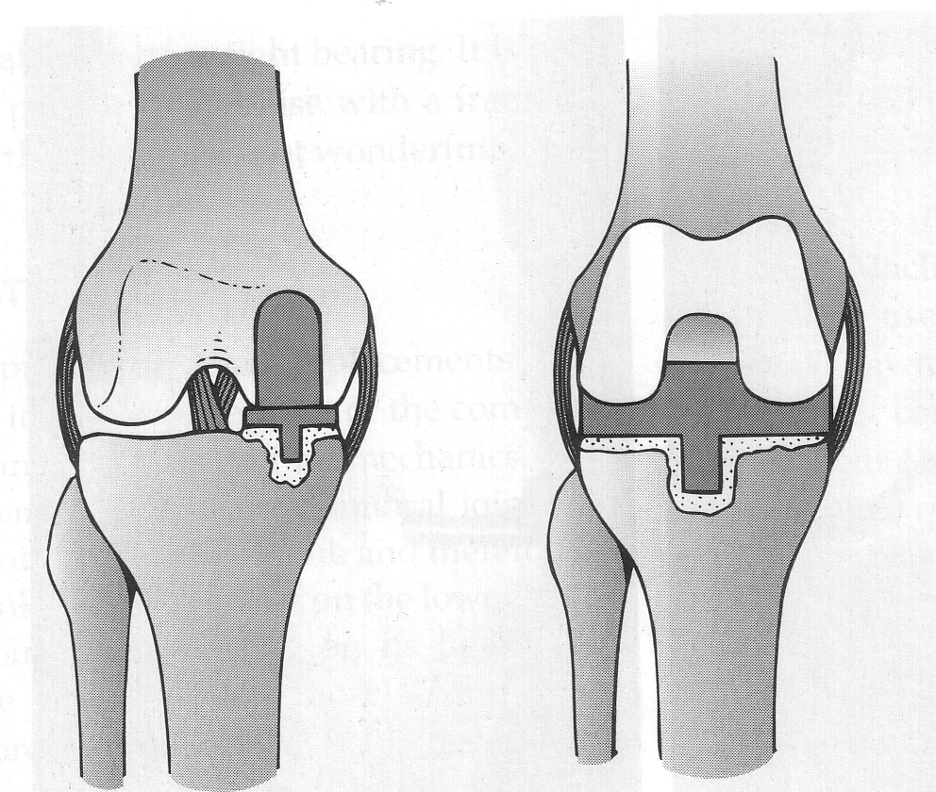
Before coming into hospital

Arrangements to make at home:

- Re-arrange your cupboards and drawers so that everyday items such as cooking utensils are at waist height to reduce the amount of excessive bending and reaching you to do.
- Make sure you have a good stock of food in or freeze plated meals for convenience.
- It is essential that you arrange for family or friends to support you when you are discharged.
- If you live alone this would mean someone would need to stay with you for at least the first night after discharge.
- Think about how you will manage the daily tasks that you need to do at home. Think about who may be able to help you with things such as shopping, vacuuming and bed changing.
- Speak to family or friends about the assistance you may want from them. However, if you are unable to find the help you require, please mention it pre-operatively to the nursing staff or a therapist.
- Remove or fasten down rugs and loose carpets to reduce the risk of tripping over them.
- Organise a firm, high, chair with arms for ease of standing up and sitting down.
- Arrange your own transport home on the day of discharge.
The precise time to organise this will be discussed with you on the ward.
- Leave your valuables at home.

Things to bring with you

- Any medication you are taking, such as inhalers, blood pressure or diabetic medication.
- Nightwear - in case of an overnight stay
- Toiletries, shaving kit.
- Dressing gown (not too long).
- Loose fitting day clothes, as you will be encouraged to dress as soon as you are able to walk. For example, skirts, shorts or jogging bottoms, not jeans.
- Slippers and sensible shoes or supportive sandals (not mules) which are easy to put on. Adjustable footwear will allow for any swelling after your operation.
- A long handled shoehorn, 'helping hand' and walking sticks, if you already have these at home.
- This booklet.
- A small amount of money for the phone / TV card.
- Books, magazines or something to do.

Before the operation

You will be seen at the Pre-admission Clinic where routine investigations are carried out:

- Blood tests.
- ECG (a tracing of your heartbeat).
- Swabs are taken from your forehead and nose to see if you are carrying bugs (MRSA) that are resistant to antibiotics.
- You may be commenced on iron supplements.
- An X-ray of your knee, if you have not had one done for a while.
- You will be seen by a nurse.

This clinic enables us to make sure that you are fit and well before your operation. Your notes may be reviewed by an anaesthetist prior to your operation to ensure they are happy to proceed. It also gives you the opportunity to ask us any questions that you may have.

It is also important that you attend the pre-operation knee class run by the Physiotherapy Department. This will give you an opportunity to learn the exercises you should commence and be provided with elbow crutches. You will be required to attend 2-6 sessions. Please watch the videos on the links below before attending and prepare any questions you may have.

Pre-operative knee joint replacement education

https://youtu.be/E2rhB0nn8ps

Pre / Post operation exercises and walking aid advice

https://youtu.be/8NhSkDj3QMs

Risks related to surgery

All patients consenting to surgery are entitled to know the risks involved.

The following three categories list the potential risks the patient should be aware of. These risks may not prevent you having surgery, but they can increase the potential for complications.

Risks prior to surgery

- Obesity.
- High blood pressure.
- Diabetes.
- Chest problems, such as asthma or chronic obstructive pulmonary disease.
- Leg ulcers.
- Strokes.
- Angina.
- Irregular heartbeat/heart irregularities.
- Parkinson’s disease.
- Smoking.
- Dental decay.

Research has shown that if you stop smoking two months prior to surgery you will greatly reduce the risk of complications.

The Royal College of Anaesthetists has prepared information on how to take an active role in planning and preparing for your operation. Please use the link below to access this.

Preparing for surgery – Fitter Better Sooner

https://www.rcoa.ac.uk/patients/patient-information-resources/preparing-surgery-fitter-better-sooner

Risks during surgery

- Wound infection requiring antibiotic treatment.
- Deep infection requiring major surgery, which may include removal of the joint replacement, which can result in a permanent disability.
- Blood loss, requiring transfusion.
- Heart attack, stroke or death is possible from the stress of the surgery.
- Nerve damage during surgery, which may cause a permanent weakness in the leg.
- Fractures / tendon damage / weak muscles.

Risks following surgery

- Wound infection.
- Blood clots - deep vein thrombosis / pulmonary embolism.
- Chest infection.
- Unequal leg length which may cause a limp.
- Some patients have a persistently swollen leg after surgery.
- You may have trouble bending down.
- It is normal to experience a clunking or clicking noise from your new knee replacement.
- Foot care may still be difficult after the operation.

Admission

On arrival, please report to the area stated on your letter. Some patients go to theatre from here and return to the Sandringham Unit after their operation. Others are admitted directly to the Sandringham Unit.

On admission to hospital, you may have a further blood test and then meet:

- The medical staff.
- The anaesthetist, to discuss the most appropriate anaesthetic for you.

The day of your operation

In preparation for your operation, you will not be allowed anything to eat for about six hours beforehand and only have sips of water to drink in this time.

Before your operation you will be asked to put on a theatre gown.

You will be seen by an anaesthetist who will discuss the type of anaesthetic most suitable for you and pain relief after surgery, such as:

- General anaesthetic - you will be asleep.
- Spinal anaesthetic, with or without sedation – you will be numb from your waist down. This may affect your bladder control until full sensation returns.
- Block - your operated leg will be numb for several hours after surgery.

After your operation

You may find:

- An oxygen mask on your face.
- A drip in one arm, which stays in until you are drinking normally again (about 24 hours).
- A bulky bandage around your knee - this is to reduce swelling. In most cases this is removed before you are discharge, leaving a simple dressing over the wound.

The nurses will take your blood pressure, pulse and temperature at regular intervals. It is usual to feel quite sore following major surgery of this nature. You will be offered regular pain relief to ease the soreness.

Please tell the nurses if you are in discomfort or your painkillers are not working so that your medication can be changed.

Rehabilitation

You will be assisted out of bed the day of, or day after, your operation by the physiotherapist, therapy assistant or nursing staff. You will be encouraged to regularly change your position in bed to prevent your bottom and heels from becoming sore.

Once you have recovered from the anaesthetic, try to eat a healthy diet and drink plenty of fluids in order to avoid becoming constipated.

It is beneficial to rest your knee in extension (flat on the bed) to avoid the muscles at the back of the knee from becoming tight. Movement of your operated leg, as instructed by the physiotherapist, is an essential part of the recovery programme.

You will be reminded of the exercises that you commence in the
pre-operative class. These are essential to:

- Strengthen muscles
- Increase knee range of movement in preparation for walking
- Minimise the risk of a blood clot

If appropriate, following your initial physiotherapy assessment, you will be assisted out of bed and take a few steps to your chair.

Before you are discharged from hospital you will be expected to:

- Achieve a minimum flexion (bend) of 60° to 70° knee bend.
- Achieve as close to full extension (less than 10°) of the knee as possible.
- Walk safely and independently with elbow crutches or sticks.

On discharge, you are responsible for your ongoing rehabilitation and progress and can contact the physiotherapy department on 01553 613796, if you have any questions.

Knee exercises

Advice and warnings:

- These exercises should not cause pain. You may require some assistance at first. Stop if they make your symptoms worse.
- Whilst doing the exercises, try to relax the muscles in your arms, trunk and neck.
- It is more worthwhile to exercise little and often.

Walking

You will have been given elbow crutches and shown how to use them at the pre-operative class. A physiotherapist or therapy assistant will supervise you and guide you in using them safely again post-operatively.
The sequence is always:

- Walking aid forward.
- Then operated leg.
- And finally, the un-operated leg.

Remember: C.O.G. – Crutches; Operated leg; Good leg.

When turning round, take small steps to prevent twisting your knee. Regaining a normal "walking" pattern takes time and effort, but it will improve as you persevere.

Stairs

If appropriate, you will be taught to negotiate stairs before discharge home. The correct sequence is:

- Going up - un-operated leg first, operated leg onto the same step and finally walking aid.
- Going down - walking aid down, then operated leg and finally the un-operated leg.

Whenever possible, use the banister with both walking aids in the other hand.
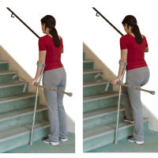
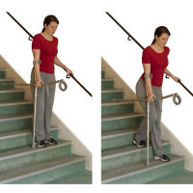

Getting in and out of chairs

You may find it beneficial to sit in a firm, high chair with arms.
Your chair at home may need to be raised, although a cushion may be enough.

1. Step back until you feel the seat on the back of your legs. Put your walking aids into one hand and reach for the chair arm with your other hand.
2. Then move backwards until comfortable. Slide your operated leg out in front of you.
3. Sit down on the front of the seat.
4. Then move backwards until comfortable.
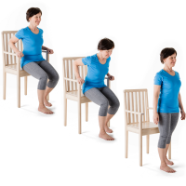

What can I do to help myself whilst on the ward?

There are many things you should do for yourself on the ward.
You should try not to become too reliant on others, but do mention any problems you are having.

Carry out the exercises given to you by the physiotherapist regularly.

Change your position on the bed or chair regularly. Elevate your leg at rest to prevent excessive swelling.

It is important that you are eating enough to help with healing and recovery. If you need assistance with eating, or you have any concerns about your food intake, please ask a member of the ward staff.
Getting on and off the toilet

Use the same routine as for sitting in a chair. A toilet frame may be provided to give a stable surface to push up from. It will usually be on temporary loan for two months and needs to be returned to the hospital. Other equipment may be issued if necessary.

Dressing

The therapist will show you how to use the appropriate equipment for dressing the operated leg; for example, a long-handled shoehorn, sock/tights aid and helping hand, if this is required. This equipment can be purchased from the Rehabilitation Service.

Bending

If you must bend to reach low objects, hold onto something stable, such as a table. Slide your operated leg behind you, then go down bending the knee of the un-operated leg.
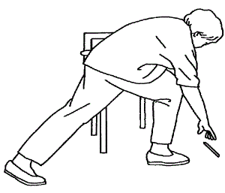

Discharge home

You will be discharged home from either the ward or the Discharge Lounge. You will be given: a GP letter, medication, ‘joint card’, dressings and clip removers (for the nurse). You will be contacted with details for your clinic review appointment after you return home.

Getting in and out of the car

- If the seat is very low, put a cushion in.
- Stand with your back to the seat; place your left hand on the back of the seat and your right hand on the seat base.
- Lower yourself onto the seat and slide backwards towards the driver’s seat as far as possible.
- Turn your bottom and slide your legs into the car.

Bathing

If you have a bath or a shower over the bath, you will need to strip wash until you can comfortably step in and out of the bath. If you have a shower cubicle, you may shower straight away after your operation.

What can I do to help myself at home?

This is a major operation; therefore, you may tire easily following discharge. Continue to do your exercises as instructed by the physiotherapist and increase your walking distances daily. Get up every hour or so during the day and have a short walk.

Try to rest on your bed for an hour each day.

Seek advice from your GP should your knee / leg becomes particularly hot, red or swollen.

Leave frequently used items on kitchen worktops and reduce the amount of bending by rearranging items in low cupboards/ fridge.

Remove clutter from walkways and ensure areas are well lit.

Try to spread household tasks evenly over the week. Avoid heavy activities such as vacuuming for the first six weeks. Do not stand for long periods and allow yourself plenty of time to rest. Do keep drinking and eating healthily to avoid constipation.

If you have any other specific questions or concerns relating to your lifestyle, please discuss this with a member of staff prior to going home.

Daily activities

The therapist will see you whilst in hospital to assess your ability to manage safely and independently on going home. Advice will be given and, where necessary, equipment supplied.

Frequently asked questions

Q Who will remove my clips or staples from my wound?

A The staples on your wound will be removed between 10 and 14 days after surgery. This can be done by the nurse at your GP surgery. You will need to arrange this appointment after you go home.

Q Will I have to come back to see the consultant?

A You will be reviewed by a surgeon six weeks after surgery. It is advised that you do not resume sport or any other active hobbies until after that time.

Q When will I be able to drive again?

A You can resume driving six weeks after your operation. It may be advisable to check with your insurance company before doing so.

Q When will I be able to fly?

A You will not be able to fly until 6 to 12 weeks after your operation to reduce the risk of deep vein thrombosis (DVT).

Q When can I return to work?

A You can normally return to work within three to six months. As each person’s work situation is different, you will need to discuss this with your consultant or GP.
Q Are there any other services that I may find useful?

A Careline/ Lifeline. This is a personal alarm network, which allows you to summon assistance in an emergency. If you would like more information on this service, please speak to your occupational therapist.

Careline Community Service Lifeline
King’s Court Lifeline Control Centre
Chapel Street Cross Keys Homes Ltd
Kings Lynn Shrewsbury Avenue
Norfolk Woodston
PE30 1EX Peterborough
Telephone: 01553 760671/616371 PE2 7BZ

Web site: careline-cs.org.uk Telephone: 01733 235085 or 396439
lifeline@crosskeyshomes.co.uk

Wiltshire Farm Foods and Oakhouse Foods. These companies provide a range of frozen ready meals which can be delivered to your door.

Wiltshire Farm Foods: Telephone: 0800 773773
Oakhouse Foods: Telephone: 01480 494197

Norfolk Medicines Support Service. This service is available for those patients registered with a GP in Norfolk. It aims to facilitate the care of people in their own home by providing a professional medicines management assessment and support service. For further information on this service, please speak to any member of ward staff or your GP.

Social Services.

Lincolnshire Social Services Telephone: 01522 782155
Cambridgeshire Social Services Telephone: 0345 045 5202
Norfolk Social Services Telephone: 0344 800 8020

Knee exercises – First stage
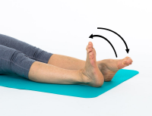
Lying on your back or sitting, bend and straighten your ankles briskly.

Repeat for 30 seconds hourly.

Complete 10 of each of the exercises
below 5 times daily.

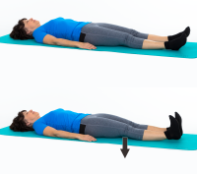
Lying on your back with legs straight, pull your feet up towards you. Push your knees down firmly against the bed tightening the muscles on the front of your thighs.

Hold for five seconds and relax.

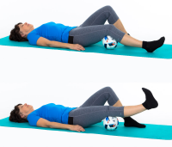
Lying on your back with a rolled-up towel or ball under your knee, pull your ankle up towards you and straighten out your knee (keeping your knee pressed onto the towel / ball).

Hold for five seconds then slowly relax.

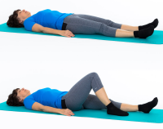
Lying on your back, bend and straighten your leg, sliding your heel towards your bottom, as pain allows.

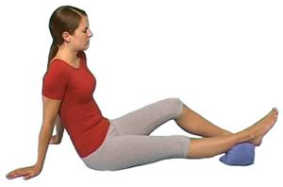
Place a rolled towel under your ankle. Straighten your knee by tightening your thigh muscles. Try to touch the bed with the back of your knee.

Hold for five seconds. Repeat ten times.

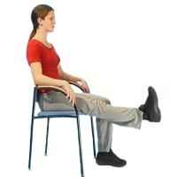
Sitting on a chair, pull your ankles up towards you, then try to straighten your knee.

Hold for five seconds, then slowly relax.

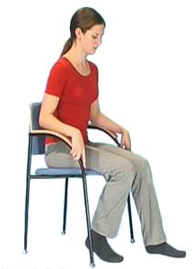
Sit on a chair with a plastic bag under the foot of your operated leg. Bend your knee as much as possible, then relax.

Repeat ten times.

Second stage exercises – please complete ten repetitions of each exercise at least three times a day.

Stand behind a chair and support yourself with both hands. Push up on your toes.

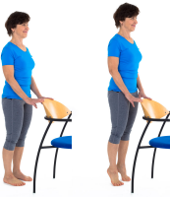

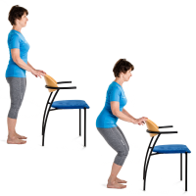
Stand behind a chair and support yourself with both hands. Slowly bend your hips and knees, trying to push your bottom back. Stand up, tightening your buttock muscles.

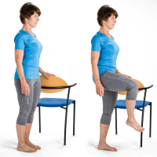
Stand behind a chair and support yourself with both hands. Bend your operated hip and knee upwards as shown. Hold for five seconds.

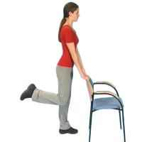
Stand. Hold onto the back of a chair and bring your operated leg slightly backwards. Bend your knee and lift your foot off the floor.

Hold for five seconds.

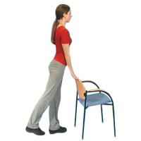
Stand in the same position as above. Push your operated leg backwards keeping the knee straight. Hold for five seconds.

Useful Contacts

NHS Choices:

Telephone: 111
Web site: www.nhsdirect.nhs.uk

Age UK:

Tavis House
1-6 Tavistock Square
London
WC1H 9NA
Telephone: For information and advice, call 0800 055 6112
Web site: www.ageuk.org.uk

Arthritis Research UK

Copeman House
St Mary's Gate
Chesterfield
Derbyshire
S41 7TD

Telephone: 0300 790 0400
Web site: www.arthritisresearchuk.org

Local Information Support Team and Falls Service (West Norfolk)

St James Clinic
Exton’s Road
King’s Lynn
Norfolk
PE30 5NU

Telephone: 01553 668673 or 01553 668557

Email: list.falls@nchc.nhs.uk

Issued by:

The Queen Elizabeth Hospital
Gayton Road
King's Lynn
Norfolk
PE30 4ET

Contact Information

Orthopaedic pre-assessment patients, please telephone 01553 613893 to cancel or change appointments

Sandringham Unit: 01553 214512 (direct line)
Physiotherapist: Can be contacted via the ward
Occupational Therapist: Can be contacted via the ward
Dietitian: 01553 613507 (direct line)
Patient Advice The Queen Elizabeth Hospital
& Liaison Service: (PALS) 01553 613351 (direct line)
email: pals@qehkl.nhs.uk
Web site: www.qeh.nhs.uk/pals

V4 – March 2023
Review March 2028
V4 – September 2022

Review – September 2027

