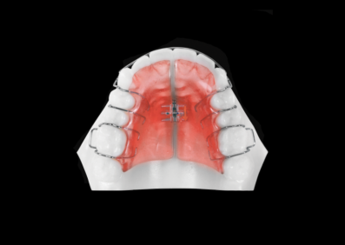
What is a URA
A URA is an upper removable appliance, made from plastic and stainless steel wire.
When will I need to wear it?
You will need to wear your brace throughout the day and during the night. You will need to remove your brace when you eat, drink or play sports including activities such as swimming. The brace will need to be removed when you brush your teeth.
How long will I need to wear it?
It usually takes approximately 6-12 months but will vary according to how severe your case is. Failed and cancelled appointments or repeated breakages of the brace will increase the length of time the treatment will take.
What will happen if I do not wear my brace?
If this appliance is not worn as prescribed, treatment will take longer to complete, therefore full compliance will ensure that treatment will not take longer than necessary.
How do I insert and remove my brace?
Always remove the brace using the clips around the back of the teeth. If you repeatedly click the brace in and out with your tongue or the wire which goes around your front teeth, this will break the wires and increase the length of time treatment will take.
Will my speech be affected?
Your speech will be different. Practice speaking with the brace in place, for example read out loud at home on your own. You may also find yourself swallowing a lot to begin with. This is quite normal and will quickly pass.
How do I clean my brace?
It is very important to keep your brace clean as well as your teeth. After you have brushed your teeth you must clean the brace with a toothbrush and a soapy liquid. There is a special cleaning product called Retainer Brite which is designed for removable appliances.
Can I eat normally?
Yes you should be able to eat normally. Take your removable brace out when eating and drinking, remembering to put the brace back in your mouth.

