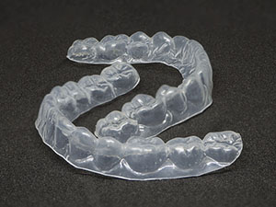
Retainers

Retainers are essential in almost all cases to help prevent tooth movement and relapse after treatment.
Retainers are fitted at the end of orthodontic treatment after the braces are removed. They can be either removable or fixed onto the teeth. The type of retainer you will have s determined by a number of factors and your orthodontist will explain which retainer is best for you.
There are two reasons for wearing retainers:
- Teeth tend to want to move back towards their original position, this is called relapse.
- As we get older our teeth may start to move unpredictably, often showing some crossing over and increased crowding.
When will I need to wear my retainer?
You will need to wear your retainers full time, morning and night for the first 3 months, removing them for eating and drinking. After eating and drinking you will need to clean your teeth and retainers and then replace them in the mouth. We recommend drinking water only with the retainers in place. After 3 months you will need to wear your retainers at night time only. We advise when the retainers are not in the mouth, they are placed in a retainer box to avoid them getting lost or broken.
How long will I need to wear my retainers?
You will need to wear your retainer life long, or for as long as you want your teeth to remain as they are after treatment.
How do I clean my retainer?
It is very important to keep your retainer clean as well as your teeth. After you have brushed your teeth you must clean the retainer with a toothbrush and a soapy liquid. There is a special cleaning product called Retainer Brite which is designed for retainers. Do not put your retainer in boiling water as it will melt.
How often will I need to be reviewed?
Your Orthodontist is responsible for a retention period of 12 months, after this period you will be discharged. Any repairs or new retainers can be done by your dentist or a dentist who specialises in orthodontics. Once discharged the hospital will NOT be able to replace or repair your retainers.
- Remember at your review appointments, to bring your retainers with you.

