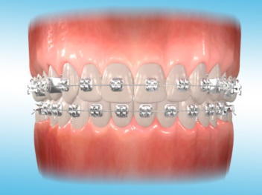
Fixed Appliance
What is my brace made up of?
Your brace is made up of small brackets glued to your teeth. The arch wire runs through special slots in the brackets which exerts force on the bracket which in turn moves the tooth. The arch wire is tied to the slot using elastics. These elastics come in many different colours.
Will it hurt?
It is usual for the teeth to be uncomfortable for a few days after the brace is first fitted. A soft diet will help and painkillers, if required, until symptoms settle. Some parts of the brace may cause discomfort to your gums and lips causing sore spots up to 1 week after your brace has been fitted. You will be given some wax to place over the part of the brace that is causing the discomfort.
How do I clean my teeth?
Since the brace is fixed you cannot remove it to brush your teeth. It is extremely important to spend extra time brushing all around the brace and the gums. If plaque and food debris builds up then your gums will start to bleed and your teeth may decay. Special brushes, fluoride mouthwashes for daily use and disclosing tablets are advised.
What about sports?
It is essential an orthodontic mouth guard is worn when playing contact sports.
How long will I have the brace on?
It usually takes between 18-24 months but may vary depending on how severe your case is. Failed and cancelled appointments or repeated breakages of the brace will increase the length of treatment time.
Is there anything I should avoid and can I eat normally?
Eating the wrong food damages or breaks your brace. Avoid eating sticky, chewy or sugary foods such as: Chewing gum, Haribo’s, Toffee, Mars bars or Snickers along with any hard foods such as: Apples, Raw carrots, French bread or Crusty rolls. At first cut food into small bite size pieces and keep to a soft diet throughout your treatment. Food may build up in the brackets and between the teeth therefore careful cleaning to remove this is required. Nail biting and pen chewing can damage or break your brace. Avoid fizzy drinks and natural fruit juices as these are high in sugar and can be acidic, leading to tooth decay and erosion. If you have a fizzy drink, have it with a meal and drink it through a straw. Water and milk are the safest drinks.
Why should I look after my mouth when I have a brace?
It is important to take time and effort to keep your teeth and braces clean. This will avoid problems such as dental decay, inflamed gums, and tooth decalcification. Decalcification is loss of mineral calcium from the tooth surface. This may leave white marks on your teeth after the brace is removed.
It is also important to have routine dental examinations with your regular dentist while having orthodontic treatment. This is to make sure your teeth stay healthy.

