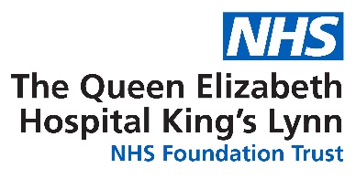

Workforce Race Equality Standard (WRES) and Workforce Disability Equality Standard (WDES)

2023 - 2024

NHS Workforce Race Equality Standard

Implementing the Workforce Race Equality Standard (WRES) is a requirement for NHS commissioners and NHS healthcare providers including independent organisations, through the NHS standard contract.

The NHS Equality and Diversity Council announced on 31 July 2014 that it had agreed action to ensure employees from black and minority ethnic (BME) backgrounds have equal access to career opportunities and receive fair treatment in the workplace.

This is important because studies shows that a motivated, included and valued workforce helps deliver high quality patient care, increased patient satisfaction and better patient safety.
In April 2015, after engaging and consulting with key stakeholders including other NHS organisations across England, the WRES was mandated through the NHS standard contract, starting in 2015/16. From 2017, independent healthcare providers are required to publish their WRES data.

NHS providers are expected to show progress against a number of indicators of workforce equality, including a specific indicator to address the low numbers of BME board members across the organisation.

The data provided within the report is that from our staff survey 2023.

Ethnically diverse and Ethnic minority
WRES Indicator |  |  | 2017 | 2018 | 2019 | 2020 | 2021 | 2022 | 2023 | TREND
5 | In the last 12 months, how many times have you personally experienced harassment, bullying or abuse at work from patients, relatives, or the public | BME | 40.4% | 37.4% | 28.8% | 23.4% | 36.8% | 43.4% | 38.6% | 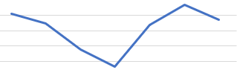
 |  | WHITE | 31.2% | 30.4% | 34% | 36.9% | 25.0% | 25.8% | 27.2% | 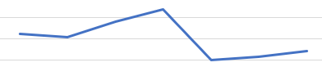
6 | Percentage of staff experiencing harassment, bullying or abuse from staff | BME | 27.2% | 29.1% | 37.2% | 29.1% | 34.1% | 33.7% | 32.6% | 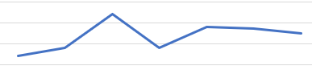
 |  | WHITE | 28.4% | 31.1% | 29.4% | 27.7% | 29.9% | 27.3% | 28% | 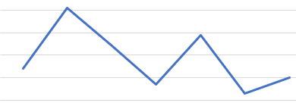
7 | Does your organisation act fairly with regard to career progression/ promotion? | BME | 55.3% | 43.2% | 46.5% | 45.6% | 39.2% | 47.9% | 50.9% | 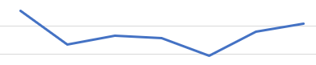
 |  | WHITE | 62.7% | 52.0% | 55.4% | 56.0% | 58.5% | 57.3% | 56.1% | 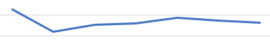
8 | In the last 12 months have you personally experienced discrimination at work from a manager, team leader or other colleague | BME | 16.8% | 16.8% | 17.2% | 18.7% | 21.1% | 19.9% | 19.9% | 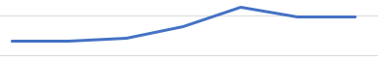
 |  | WHITE | 10.4% | 9.1% | 7.5% | 6.6% | 6.9% | 7.6% | 8.6% | 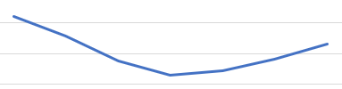

Indicator 5 - The percentage of staff experiencing harassment, bullying or abuse from patients, relatives or the public in last 12 months.

The percentage of staff who experienced harassment, bullying or abuse from patients, relatives or the public in the last 12 months was significantly higher for BME staff, 38.6%, than for White staff, 27.2%.

In terms of the percentage of BME staff who experienced harassment, bullying or abuse from patients, relatives or the public in the last 12 months, there was a 4.8% decrease from 2022.

Indicator 6 - The percentage of staff who experienced harassment, bullying or abuse from other staff in the last 12 months.

The percentage of staff who experienced harassment, bullying or abuse from other staff in the last 12 months was significantly higher for BME staff, 32.6%, and for White staff, 28%.

In terms of the percentage of BME staff who experienced harassment, bullying or abuse from other staff in the last 12 months, there is an improvement of 1.1% from 2022.

Indicator 7 The percentage of staff who believed that the trust provided equal opportunities for career progression or promotion.

The percentage of staff who believed that the trust provided equal opportunities for career progression or promotion was significantly lower for BME staff, 50.9%, than for White staff, 56.1%.

In terms of the percentage of BME staff who believed that the trust provided equal opportunities for career progression or promotion, there is a 3% improvement from 2022.

Indicator 8 - The percentage of staff who personally experienced discrimination at work from a manager, team leader or other colleagues.

The percentage of staff who personally experienced discrimination from other staff in the last 12 months was significantly higher for BME staff, 19.9%, than for White staff, 8.6%.

In terms of the percentage of BME staff who personally experienced discrimination from other staff in the last 12 months, there has been no movement from 2022.

Action Plan
 | WRES Indicator | Action
5 | The percentage of staff experiencing harassment, bullying or abuse from patients, relatives or the public in last 12 months. | - Re engagement of the Trust’s ‘No Excuse for Abuse’ campaign, working collaboratively with external organisations and ICS.
6 | The percentage of staff who experienced harassment, bullying or abuse from other staff in the last 12 months. | - Development of QEH ‘Restorative Just Culture’ programme.  - Developing a culture toolkit to engage with managers and colleagues to ensure we are treating each other in line with the trust Values.  - Continue the development of our staff networks.
7 | The percentage of staff who believed that the trust provided equal opportunities for career progression or promotion. | - Review ‘REACH’ development programme.  - Continue with our diverse interview panel and look to include Culture ambassadors to support this.
8 | The percentage of staff who personally experienced discrimination at work from a manager, team leader or other colleagues. | - Continue to raise awareness of our blended ‘Freedom to Speak up’ offering.

To support our Culture improvement plan we will be developing a team of Culture Ambassadors throughout the trust.

 |  | 4a percentage of staff who experience at least one incident of harassment, bullying or abuse from public, colleagues, and patients
WDES | 2018 |  |  | 2019 |  | 2020 |  | 2021 |  | 2022 |  | 2023 |  | Trend
 | Disabled |  | Non-  disabled | Disabled | Non-  disabled | Disabled | Non-  disabled | Disabled | Non-  disabled | Disabled | Non-  disabled | Disabled | Non-  disabled
Public | 38.1% |  | 29.9% | 35.6% | 28.0% | 26.5% | 25.0% | 33.8% | 24.7% | 31.6% | 28.3% | 33.1% | 28% | Disabled  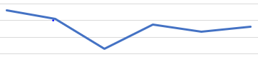  Non-disabled  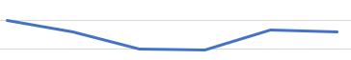
Managers | 26.2% |  | 15.1% | 23.2% | 12.2% | 17.7% | 13.2% | 22.6% | 12.9% | 24.3% | 11.0% | 18.2% | 10.6% | Disabled  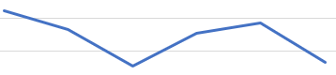  Non-disabled  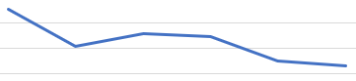
Colleagues | 32.6% |  | 21.5% | 37.9% | 20.2% | 27.9% | 18.9% | 33.0% | 20.4% | 32.4% | 19.9% | 33.7% | 22.6% | Disabled  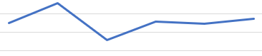  Non-disabled  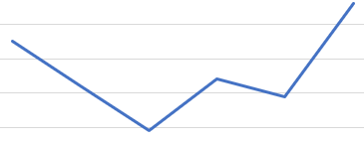

WDES Indicator |  |  | 2018 | 2019 | 2020 | 2021 | 2022 | 2023
4b | Percentage of disabled staff compared to non-disabled staff saying that the last time they experienced harassment, bullying or abuse at work, they or a colleague reported it. | Disabled | 43.1% | 43.2% | 49.7% | 51.5% | 48.0% | 51.9% | 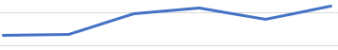
 |  | Non-disabled | 42.7% | 49.1% | 49.1% | 43.7% | 48.3% | 55.6% | 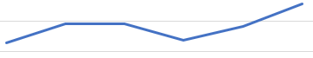
5 | Percentage of disabled staff compared to non-disabled staff believing that their organisation provides equal opportunities for career progression or promotion | Disabled | 46.2% | 48.9% | 49.8% | 49.7% | 48.7% | 49.2% | 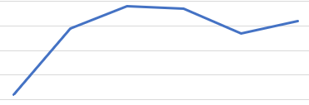
 |  | Non-disabled | 51.9% | 55.6% | 55.8% | 57.1% | 57.1% | 56.8% | 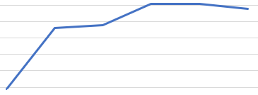
6 | Percentage of disabled staff compared to non-disabled staff saying that they have felt pressure from their manager to come to work, despite not feeling well enough to perform their duties | Disabled | 37.1% | 34.6% | 29.4% | 34.6% | 30.3% | 31.6% | 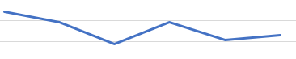
 |  | Non-disabled | 22.3% | 19.1% | 20.2% | 24.7% | 24.8% | 22.0% | 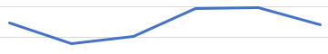
7 | Percentage of disabled staff compared to non-disabled staff saying that they are satisfied with the extent to which their organisation values their work | Disabled | 21.0% | 28.1% | 28.4% | 24.7% | 25.3% | 28.5% | 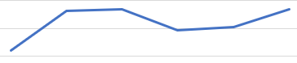
 |  | Non-disabled | 36.3% | 41.1% | 46.5% | 35.5% | 37.9% | 39.0% | 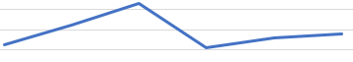
8 | Percentage of disabled staff saying that their employer has adequate adjustments to enable them to carry out their work | Disabled | 70.2% | 73.8% | 75.4% | 66.7% | 70.6% | 69.8% | 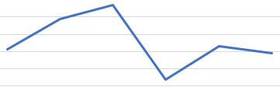
9a | The staff engagement score for disabled staff | Disabled | 6.1% | 6.2% | 6.6% | 6.2% | 6.1% | 6.3% | 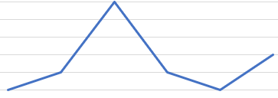
 |  | Non-disabled | 6.6% | 6.9% | 6.9% | 6.7% | 6.6% | 6.8% | 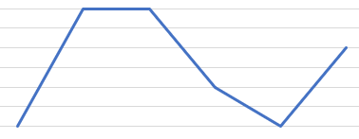

Indicator 4a -Percentage of disabled staff compared to non-disabled staff experiencing harassment, bullying or abuse from manager, other colleagues, patients and service users

Percentage of disabled staff compared to non-disabled staff experiencing harassment, bullying or abuse from manager, other colleagues, patients and service users.

Public – Increased by 1.5% from 2022
Managers – declined by 6.1% from 2022
Colleagues – increased by 1.3% from 2022

Indicator 4b - Percentage of disabled staff compared to non-disabled staff saying that the last time they experienced harassment, bullying or abuse at work, they or a colleague reported it.

The percentage of disabled staff compared to non-disabled staff saying that the last time they experienced harassment, bullying or abuse at work, they or a colleague reported it, for disabled staff, 51.9%, and for non-disabled staff, 55.6%.

In terms of the percentage of disabled staff who experienced harassment, bullying or abuse from other staff saying that the last time they experienced harassment, bullying or abuse at work, they or a colleague reported it, there was an increase of 3.9% from 2022.

Indicator 5 - Percentage of disabled staff compared to non-disabled staff believing that their organisation provides equal opportunities for career progression or promotion

Percentage of disabled staff compared to non-disabled staff believing that their organisation provides equal opportunities for career progression or promotion, was significantly lower for disabled staff, 49.2%, than for non-disabled staff, 56.8%.

In terms of the percentage of disabled staff compared to non-disabled staff believing that their organisation provides equal opportunities for career progression or promotion, there was improvement by 0.5% from 2022.

Indicator 6 - Percentage of disabled staff compared to non-disabled staff saying that they have felt pressure from their manager to come to work, despite not feeling well enough to perform their duties

Percentage of disabled staff compared to non-disabled staff saying that they have felt pressure from their manager to come to work, despite not feeling well enough to perform their duties was significantly higher for disabled staff, 31.6%, than for non-disabled staff, 22%.

In terms of percentage of disabled staff compared to non-disabled staff saying that they have felt pressure from their manager to come to work, despite not feeling well enough to perform their duties, there was an increase of 1.3% from 2022.

Indicator 7 - Percentage of disabled staff compared to non-disabled staff saying that they are satisfied with the extent to which their organisation values their work

Percentage of disabled staff compared to non-disabled staff saying that they are satisfied with the extent to which their organisation values their work was significantly lower for disabled staff, 28.5%, than for non-disabled staff, 39%.

In terms of percentage of disabled staff compared to non-disabled staff saying that they are satisfied with the extent to which their organisation values their work, there was a increase of 3.2% from 2022.

Indicator 8 - Percentage of disabled staff saying that their employer has adequate adjustments to enable them to carry out their work

Percentage of disabled staff saying that their employer has adequate adjustments to enable them to carry out their work, there was an decrease of 0.8% from 2022.

Indicator 9 - The staff engagement score for disabled staff

The staff engagement score for disabled staff was similar for disabled staff, 6.3% then for non-disabled staff, 6.8%

In terms the staff engagement score for disabled staff, there was a increase of 0.2 above from 2022.
Action Plan

 | WDES Indicator | Action
4a | Percentage of disabled staff compared to non-disabled staff experiencing harassment, bullying or abuse from manager, other colleagues, patients and service users | - Recognise and celebrate ‘Disability History Month’ engaging through colleagues and managers  - An opportunity to complete a site or department tour prior to joining or applying for a role
4b | Percentage of disabled staff compared to non-disabled staff saying that the last time they experienced harassment, bullying or abuse at work, they or a colleague reported it. | - Review of sensory impairment training session for clinical and non-clinical staff
5 | Percentage of disabled staff compared to non-disabled staff believing that their organisation provides equal opportunities for career progression or promotion | - Continue to raise awareness of opportunities available  - Raise awareness of being an ‘Inclusive Employer’ and the use and introduction of the Culture Ambassadors
6 | Percentage of disabled staff compared to non-disabled staff saying that they have felt pressure from their manager to come to work, despite not feeling well enough to perform their duties | - Managers to utilise ‘wellbeing conversations’ to ensure staff thrive within the workplace  - Disability staff network to signpost FTSU (Freedom to Speak Up) guardian and champions.  - Coach & engage managers around the use of reasonable adjustments and the wellbeing passports
7 | Percentage of disabled staff compared to non-disabled staff saying that they are satisfied with the extent to which their organisation values their work | - Review of the Introduction of AccessAble that was launched last year 2023
8 | Percentage of disabled staff saying that their employer has adequate adjustments to enable them to carry out their work | - Continue to raise awareness of the Trusts ‘Health and Wellbeing Passport’  - Disability staff network to raise awareness for signposting for supporting staff including Access to Work
9 | The staff engagement score for disabled staff | - Advocacy and representation for improvement work within the organisation

