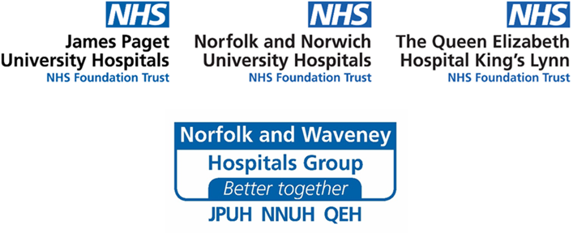
Frequently asked questions for patients who are waiting to come into hospital for an operation
How far down the waiting list am I?
Our clinical teams are going through the waiting lists very carefully and patients will be seen depending on the state of their health. This means those with the greatest clinical need will be seen first. All waiting lists are being reviewed regularly so this means that your position on the waiting list may change depending on who else is referred so unfortunately, we can’t say where you are on the list.
Can my care be transferred to another NHS organisation, with a shorter waiting list?
Yes. We may be able to transfer your care to another NHS organisation and the Queen Elizabeth Hospital, Norfolk and Norwich University Hospitals and James Paget University Hospitals are working closely to make sure that the waiting times are as even as possible between the three sites.
We will ask you about transferring your operation if this is relevant to your type of care. Other hospital trusts may also have significant waiting lists for treatment (due to the impact of the pandemic) and not all services are available at all three hospitals, so this is not always possible.
I have received a letter that says my operation could be transferred to another hospital. Where would this be?
Your operation could be carried out at James Paget University Hospitals, Norfolk and Norwich University Hospitals or the Queen Elizabeth Hospital, which are all within Norfolk and Waveney.
My situation has deteriorated, or I am in pain; can I be brought forward on the waiting list?
If your symptoms get worse while you are on a waiting list, please contact your Consultant’s secretary directly (see telephone numbers below). They will arrange for your case to be reviewed and your Consultant will consider whether they can bring your operation forward. Please do not go to your GP if you want your hospital treatment to be brought forward.
Contact your Consultant’s Secretary via the Hospital main switchboard:
JPUH: 01493 452452
NNUH: 01603 286286
QEH: 01553 613613
Please note that not all the secretaries work full time, and you may be asked to leave an answerphone message, and some will get back to you in five working days.
If you are worried about your general health or another condition (not the one that you are waiting for an operation for) or your symptoms rapidly become worse, please contact your GP or NHS 111 for advice.
If it is a life-threatening emergency, always call 999.
Can I have my operation at a private hospital?
This will depend on your individual situation. However, private healthcare is not covered by the NHS, and you would need to arrange this yourself and pay the associated costs.
You can get private treatment from a consultant or specialist without being referred by your GP. But the British Medical Association (BMA) believes it is best practice for patients to be referred for specialist treatment by their GP because they know your medical history and can advise you if a referral is necessary.
If you decide to receive treatment by a private healthcare provider for the condition for which you are on the waiting list, please contact your Consultant’s secretary directly (see telephone numbers above).
Do I need to be vaccinated against COVID-19 to have my operation?
No, a vaccination is not required. You will be contacted before your admission to advise you what you need to do before you come into hospital.
Whilst it is not required before having an operation, everyone that is eligible to receive the COVID-19 vaccine is advised to get it when they can to give them the best protection against the virus.
Do I need to do anything before I come into hospital?
We will contact you ahead of your admission, to advise you of what you need to do before you come to the hospital. We will also be asking you some questions, to ensure that we don’t need to take extra precautions with your care.
What measures are in place to manage the spread of COVID-19 around the hospitals?
We are taking a range of measures to shield our patients and staff from COVID-19 when in our care. This includes:
- Physically distancing and separating as much as possible our care for patients who have tested positive for COVID-19 or who may have symptoms of COVID-19, and patients being treated for planned care
- Every patient will be isolated and tested for coronavirus prior to admission for a planned procedure
- We have created designated, elective wards and theatres to minimise the risk to patients undergoing elective surgery and procedures
- Our staff use necessary personal protective equipment (PPE) to keep our patients and teams safe
- Our staff are well trained in how to limit the spread of infection in hospital and follow strict infection prevention protocols
- Hospital theatres, equipment and wards are frequently deep cleaned, in line with national guidance
- We are ensuring the right levels of staffing and equipment are in place so that your treatment or procedure can take place safely

Do I need to wear a mask/face covering when I come to hospital?
Yes. Please be advised that you are required to wear a mask or face covering at all times when in the hospital, except when you are in a hospital bed, or if you are exempt.
Is my treatment going to change/be worse because you’re trying to rush through patients?
No. We will always maintain the same high and excellent standards of care you would ordinarily expect to receive. You will never be offered substandard or inappropriate treatment because of waiting list pressures.
If I contact the hospital on behalf of someone else, what information do I need to provide so that you are able to provide me with an update about the patient?
We will need to get the consent from the patient by speaking to them, so we are able to gain their permission to disclose any information. If you hold legal power of attorney for health and wellbeing, we will need to see a copy of the relevant documentation.
What do I do if I want to make a formal complaint about my treatment?
In the first instance, please contact the hospitals Complaints Departments:
JPUH:
PALS and Complaints Team
James Paget University Hospitals
Lowestoft Road
Gorleston
NR31 6LA
01493 453240
pals@jpaget.nhs.uk
NNUH:
The PALS and Complaints Manager
Norfolk and Norwich University Hospital
Colney Lane
Norwich
NR4 7UY
01603 289036
palsandcomplaints@nnuh.nhs.uk
QEH:
PALS Office
The Queen Elizabeth Hospital
Gayton Road
King’s Lynn
PE30 4ET
01553 613351 or 01553 613343
pals@qehkl.nhs.uk

The team will be able to listen to your concerns and escalate these, as appropriate.
My mental health is suffering; I am depressed or more anxious because of my wait
You will help yourself by looking after your physical and mental health, especially if you are waiting for surgery, as this can improve your recovery.
It's important that you ask for help if you feel you need it. Please keep in touch with your GP or mental health professional if you are already under their care for depression or anxiety.
If this is a new change, please contact our local Wellbeing service. You can refer yourself online at www.wellbeingnands.co.uk or phone them on 0300 123 1503.
There is also a range of mental health support available locally - please look at the website for more information.
General information
For general information about COVID-19 please see the Norfolk and Waveney care system website:
www.norfolkandwaveneyccg.nhs.uk
For more information about our hospitals, please visit our websites:
www.qehkl.nhs.uk
www.nnuh.nhs.uk
www.jpaget.nhs.uk

