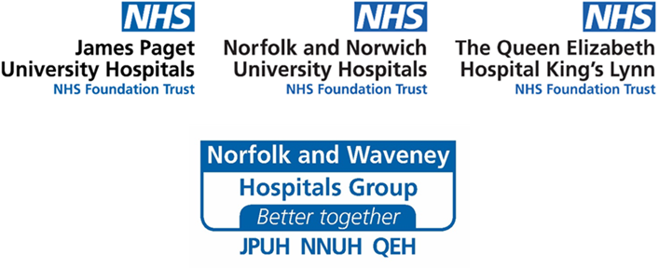
Acute Trust Waiting Times
You have been given this leaflet because are placed on the waiting list for an operation or procedure at one of the Norfolk and Waveney Acute Hospitals:
James Paget University Hospital Foundation Trust (JPUH), Norfolk and Norwich University Hospitals Foundation Trust (NNUH), or the Queen Elizabeth Hospital Foundation Trust (QEH).
We are sorry that our waiting lists have grown longer because of the pandemic. This means that you may have to wait for your operation.
What happens now?
Your case will be continuously reviewed by your clinical team to work out how urgently your operation needs to be undertaken. We need to treat patients with the most urgent conditions like cancer first. This means that some patients will have to wait longer than we would like for their treatment. We may not yet be able to give you a clear idea of when your operation/procedure will take place.
We apologise for this and thank you for your patience.
Every effort is being made to reduce waiting times for patients. All of our hospital teams across Norfolk and Waveney are working together and we are putting on additional lists with the aim to get to you as soon as possible.
Some of our consultants work across the JPUH, NNUH and QEH, so you may be offered to have your operation/procedure at any one of these hospitals.
It is important that you let your Consultant know if your condition has changed. If you think it has worsened since your operation or procedure was first arranged, please telephone your main hospital switchboard and ask to speak to your Consultant’s secretary:
JPUH: 01493 452452 - or ask for the Admissions Team who will locate your referral and direct you to your Consultant’s secretary.
NNUH: 01603 286286 - and ask to speak to your Consultant’s secretary
QEH: 01553 613613 - If you are unclear of whom you need to contact, please telephone the Admissions Team on 01553 613600
Please note that not all the secretaries work full time, and you may be asked to leave an answerphone message, and some will get back to you in five working days.
If you have any further concerns, please contact the Patient Advice and Liaison Service (PALS) team at your hospital. If you are leaving a message on their answerphone please speak clearly and calmly, not forgetting to leave your contact telephone number.

JPUH:
PALS and Complaints Team
James Paget University Hospitals
Lowestoft Road
Gorleston
NR31 6LA
01493 453240
pals@jpaget.nhs.uk
NNUH:
The PALS and Complaints Manager
Norfolk and Norwich University Hospital
Colney Lane
Norwich
NR4 7UY
01603 289036
palsandcomplaints@nnuh.nhs.uk
QEH:
PALS Office
The Queen Elizabeth Hospital
Gayton Road
King’s Lynn
PE30 4ET
01553 613351 or 01553 613343
pals@qehkl.nhs.uk

NHS Waiting Times:
Information on waiting times and your rights can be found at the following website:
https://www.nhs.uk/using-the-nhs/nhs-services/hospitals/guide-to-nhs-waiting-times-in-england/
To access type the search term ‘NHS waiting times’ into your search engine and click on the link ‘Guide to NHS waiting times in England - NHS’

